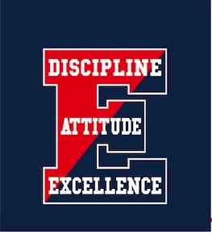Central Bucks High School East

Band Parents Association

Band Program Ads:

* Full Page (7” x 9.5”) Color - Outside Back Cover $350
* Full Page (7” x 9.5”) Color - Inside Back Cover $300
* Full Page (7” x 9.5”) Black & White $250
* Half Page (7” x 4.65”) Black & White $180
* Quarter Page (3.5” x 4.65”) Black & White $120
* Business Card (3.5” x 2”) Black & White $80

Business Name

Contact Person

Email Address

Phone Number

**Please make checks payable to: CB EAST BAND PARENTS ASSOCIATION**

Amount enclosed: $____________ Check # ______________ Date: ______________

Name of Band Member/Family Representative:

Ad copy: ❑ Enclosed ❑ Sending via US Mail ❑ Emailing

Other arrangements - describe:

⏵NOTE: If providing ads digitally, *which is not mandatory* (we will happily create your ad for you), please provide it using the correct dimensions listed above specific to the size of the ad purchased in one of the following formats: JPG, PNG, TIF, WMF or BMP. Please email to: [johnkozlowski@comcast.net](mailto:CBEastMarchingBandAds@gmail.com) or send hard copy/business cards to the following location:

CB East Band Parents Association, C/O John Kozlowski

4837 E. Blossom Dr, Doylestown, PA 18902

All ads (including payment) must be in our possession by October